31.67: a) 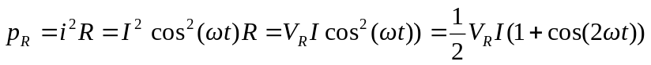
b) 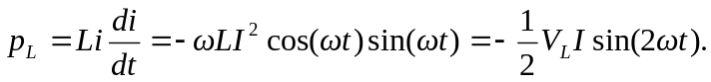
But 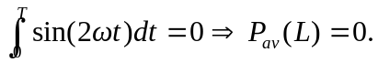
c) 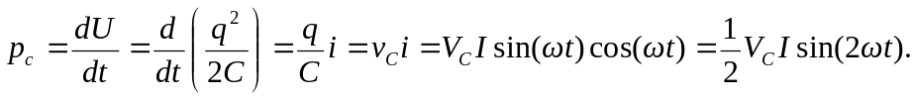
But 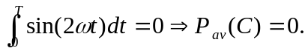
d)
But 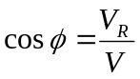 and 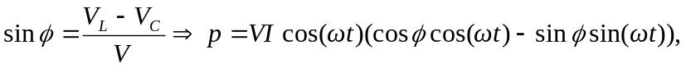
at any instant of time.

